THE NEST PROJECT

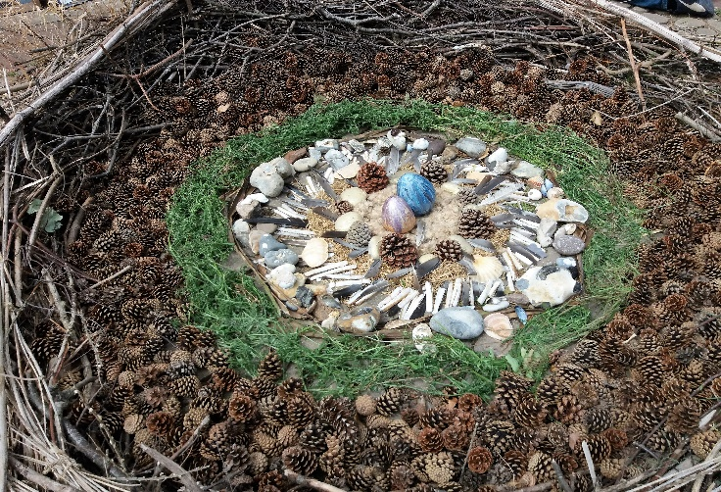
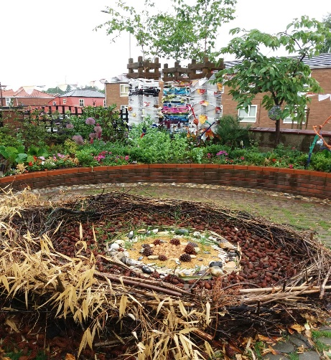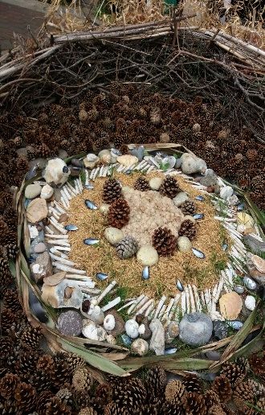
The nest project began back in the Spring of 2016. My Forest School Group set out to try and build their own giant nest along a roadside. Much collaborative design took place, mathematical reasoning was involved in making the circle and the project became a community art piece when we quickly ran out of twigs. We put up a large sign “Help us build our nest, please add sticks!”
The response was enthusiastic. Everyone from young children with their parents to teenagers joined in the build, grannies turned up with bags of sticks and cones. Others simply asked us about our progress and what we were aiming to achieve. Parents chatted to their kids on the way to school – “What built it?” “Does a dragon live there?” etc. In August 2016, the EDP ran an article about our nest after a member of the public tweeted them about the project.
Over the winter we had a good look at the original blackbird’s nest; the children noticed there were several sweet wrappers entwined. As a side project, we began making art out of the rubbish which collected around the nest. Simultaneously, collages were made from natural materials, thus exploring the differences between natural waste and man-made waste and the effect of decaying litter both in art and on the environment.
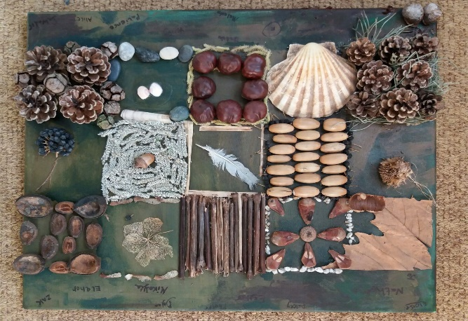
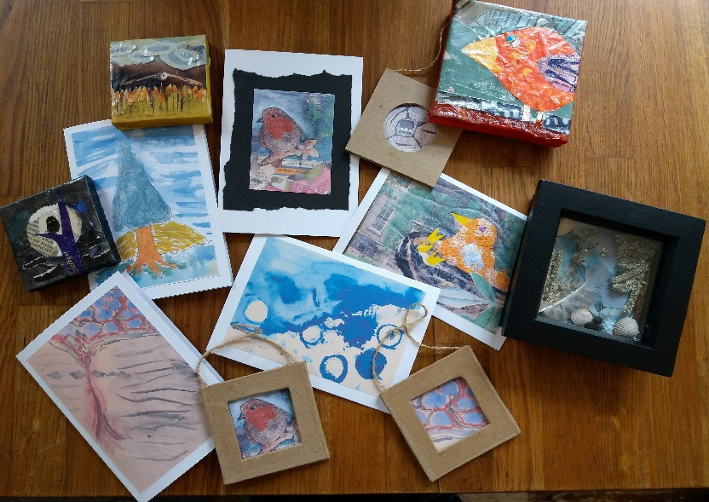
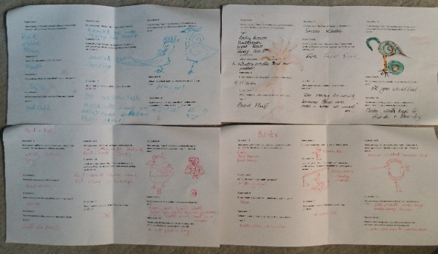
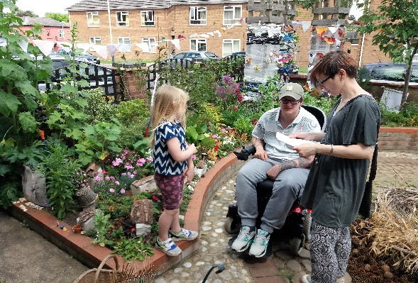
With my colleague, Rebekah Boone, qualified teacher with an MA in Art Education, we entered the project into NN Open Studios in Spring 2017. Over 2 weekends we had over 100 visitors. To highlight the work of charities working to protect the environment and campaign against plastic waste, we “litterbombed” the surrounding garden with plastic wrappers and created a small world of other nests and creatures.
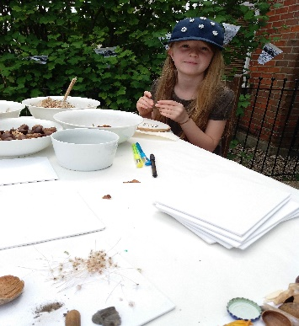
During the exhibition, visitors could discuss the project with members of the group, make their own art to take away, buy artworks made by the group, buy cards or have tea and cake whilst contemplating the giant nest. One of the children devised a questionnaire as a way of helping people to think about what we had made; over 30 people spent time completing it.
Rebekah and I, having had over 40 years’ joint experience of educational projects, would like to offer our services in helping your organisation replicate this project.
The outcomes would be:
- Producing a giant piece of land art and organising an exhibition
- Outstanding educational experiences, across the curriculum
- Breaking down barriers within or against a community/encouraging family learning
- Providing opportunities for fundraising/footfall to your organisation at the ensuing exhibition
- Raising awareness of ecological issues and educating about environmental protection
- Press/media/social media coverage.
Rebekah has been a primary teacher with lead responsibility for art and secondary/adult tutor for over 20 years. I have worked for 15 years in schools county-wide as a specialist support assistant and interpreter for deaf children/teachers. I also run a Forest School Group. We can deliver this workshop or an adaption of, to suit you. We have information about applying for grants and funds, which may help you run this project.
Please get in touch for a more detailed discussion about your organisation’s ideas and where we a project like this could lead us. Email clairegebbett@gmail.com or phone Claire (07828329636) or Bekah (07801967885). We look forward to hearing from and hopefully working with you.

